**Tutorial Map**

Built by James Bridges

Purpose:

Establish who the main character is and how he got here. Introduce the basic mechanics of the game (Movement, stealth, equipment, inventory management, combat, and health). Set the player up for the continuation of the story into the next level.

Key point of map:

* Small and abandoned rural village
  + Provides the player with a place where they are free to decide how they wish to proceed with the objective(s)
  + It is abandoned so that the player doesn’t have to worry about if an NPC is friendly or not. The only NPCs that will be roaming around will be hostile.
* Larger Church:
  + More centrally located to provide easy reference point when traversing the town
  + This is where the carriage will stop when we escape
* Props around the town:
  + Few of these to emphasize that the town is not currently occupied
  + Provide LOS blocking for stealthy gameplay
* Building with starter gear:
  + On the side of town that we entered from to ensure that the Player must traverse the first half of the map
* Road out of town:
  + Once the player kills enough of the guards, the carriage will start to travel out of town on the opposite side from where we entered. This will ensure that the player will have to traverse through the other half of the map if they didn’t choose that route before finding the starter gear.

NPCs:

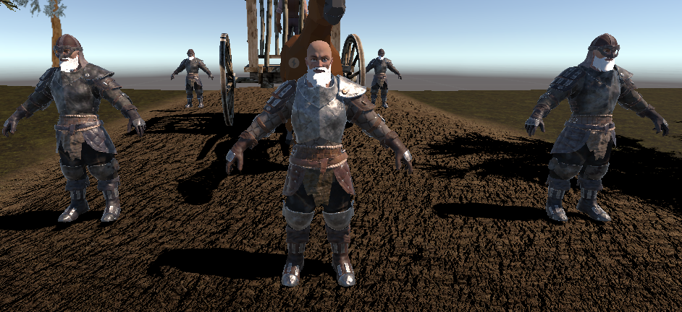

Regular Guard Guard Leader Regular Guard

Regular Guard:

* Typical thug type
* Each has their own route they patrol.

Guard Leader:

* He’s the one with the intel.
* Wider, more varied patrol pattern than the others
* More observant (wider detection area)

As of now, we currently have the following character models in game:  
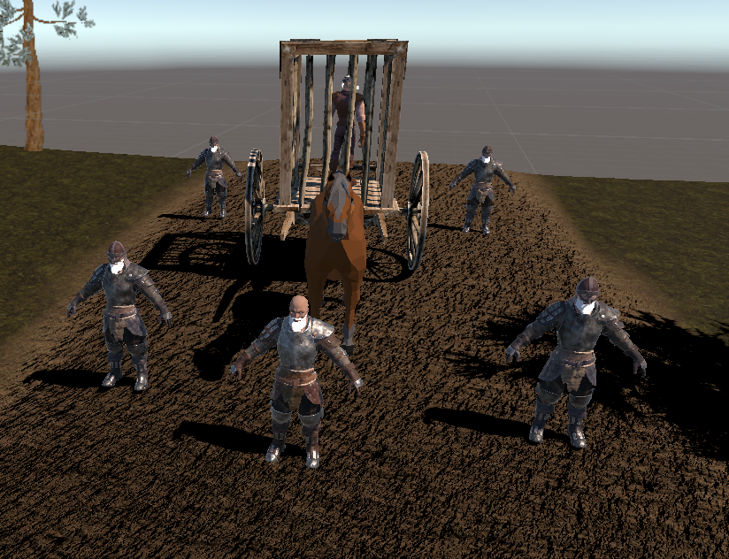

There is a horse and prison cart with our Player character inside, The Guard Leader out front, and 4 Guards surrounding the cart.

This is the minimum amount that I felt would be reasonable to use for a map of this size.

This is where we first start the game. We are imprisoned in this cart and surrounded by guards.

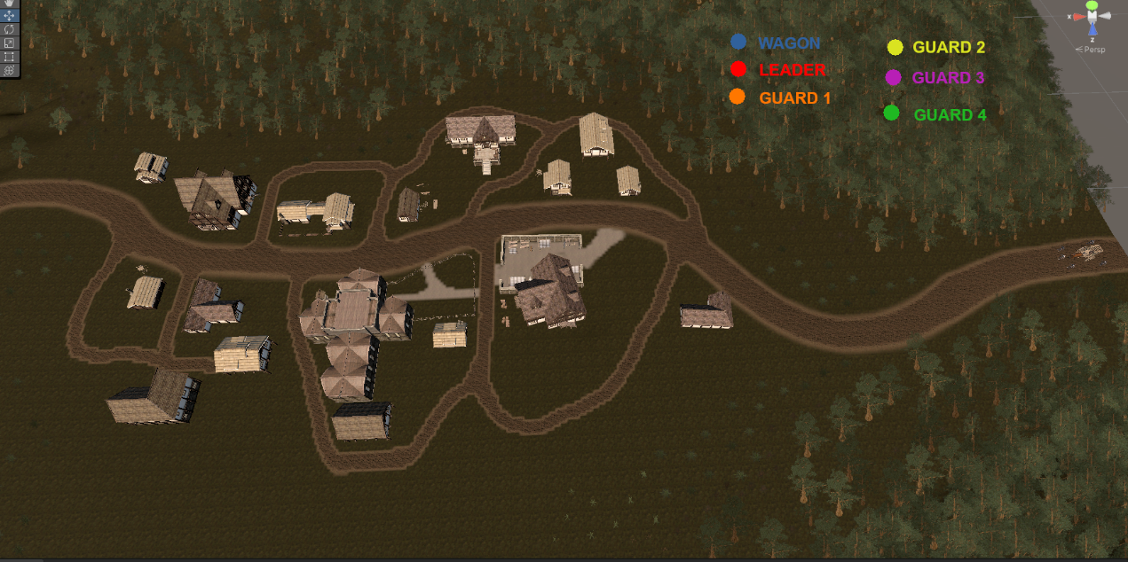

We start on the right side of the image above.

The wagon will begin to travel along the road into town.

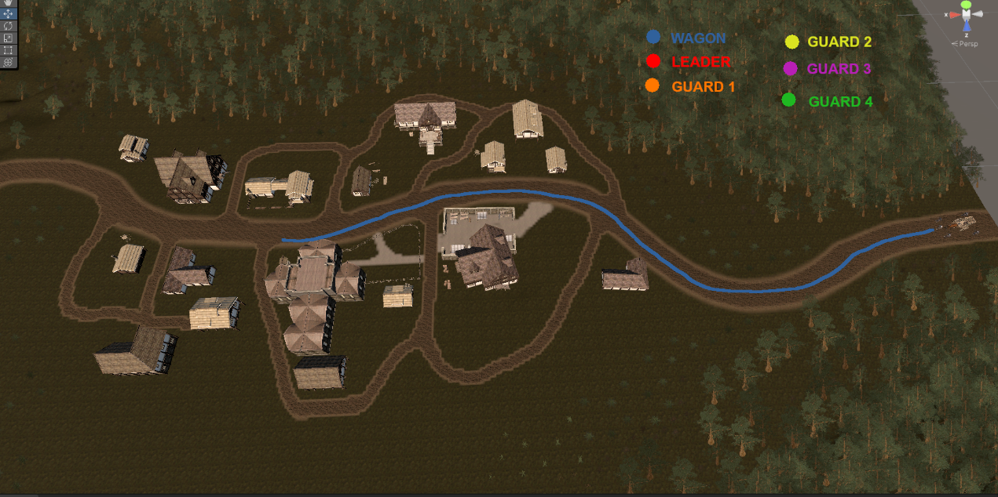

Simultaneously, all of the guards will be pathing with the wagon. The deviations don’t happen until the arrival at the church. We will go through them individually:

First, the regular Guards, in order:

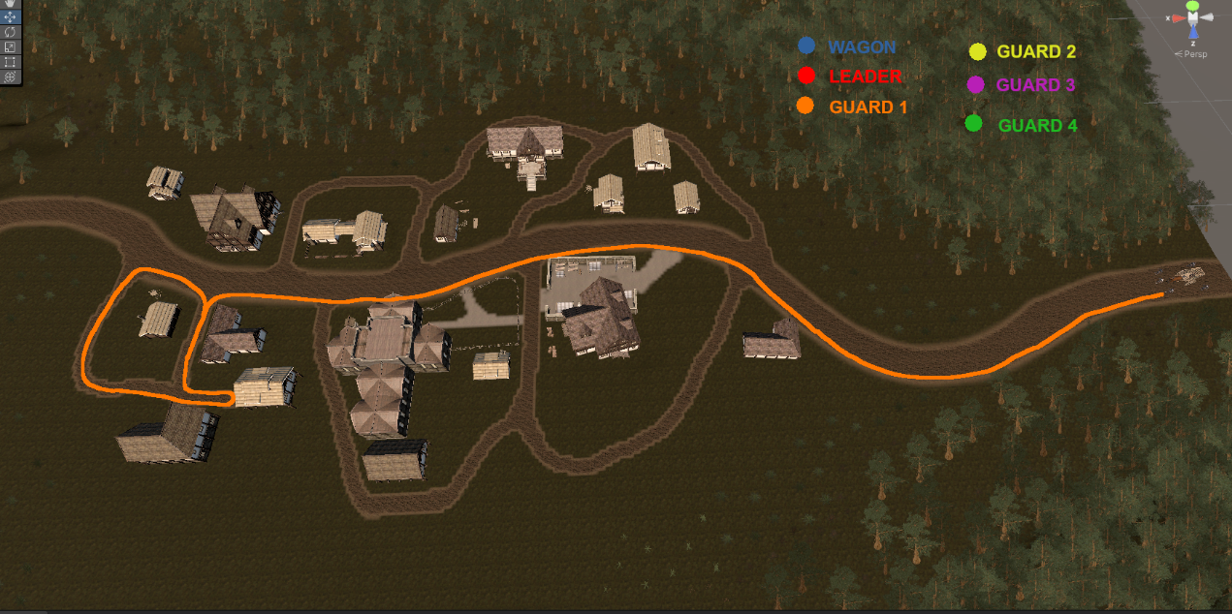

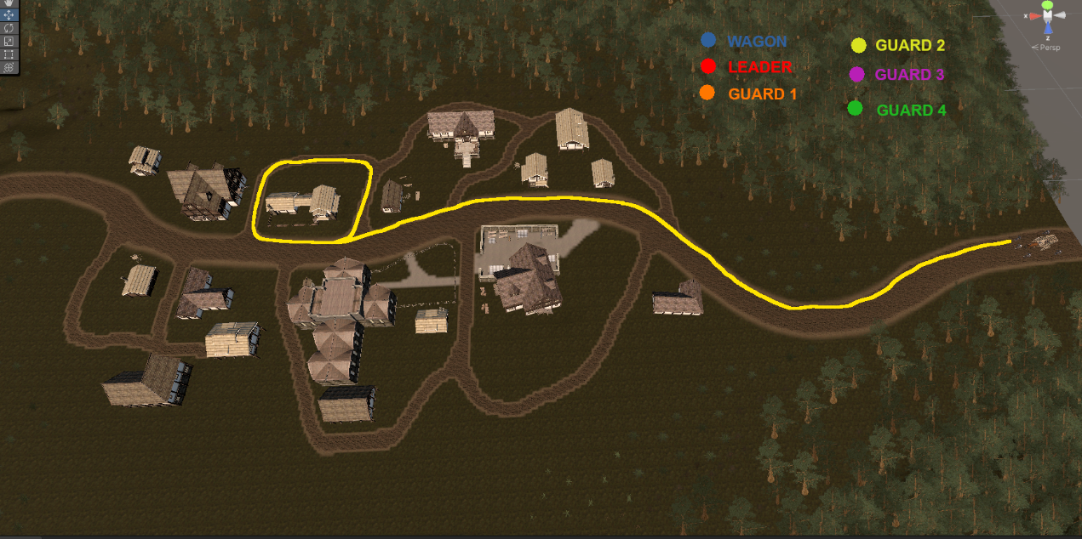

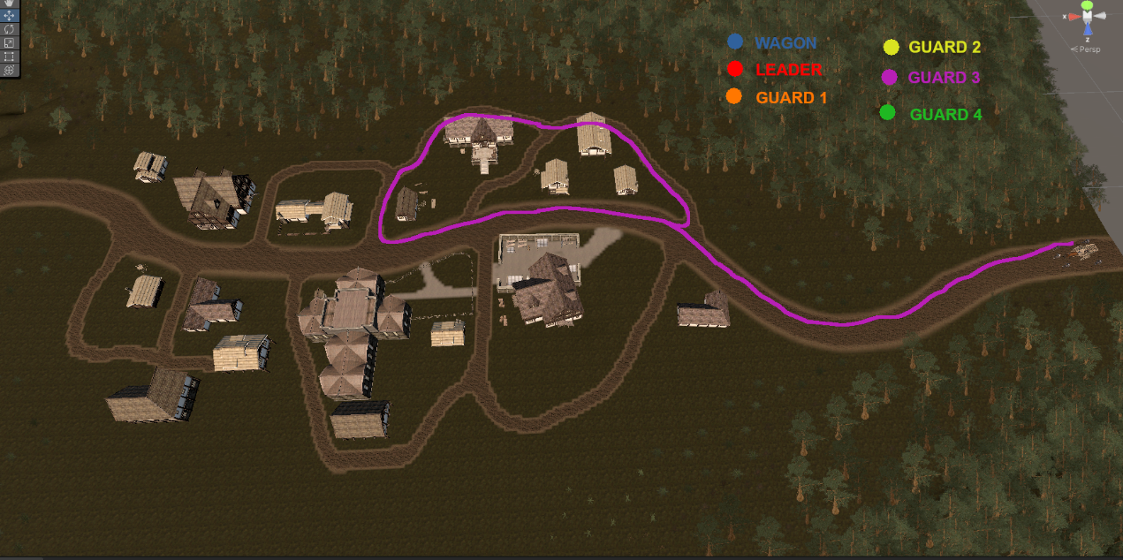

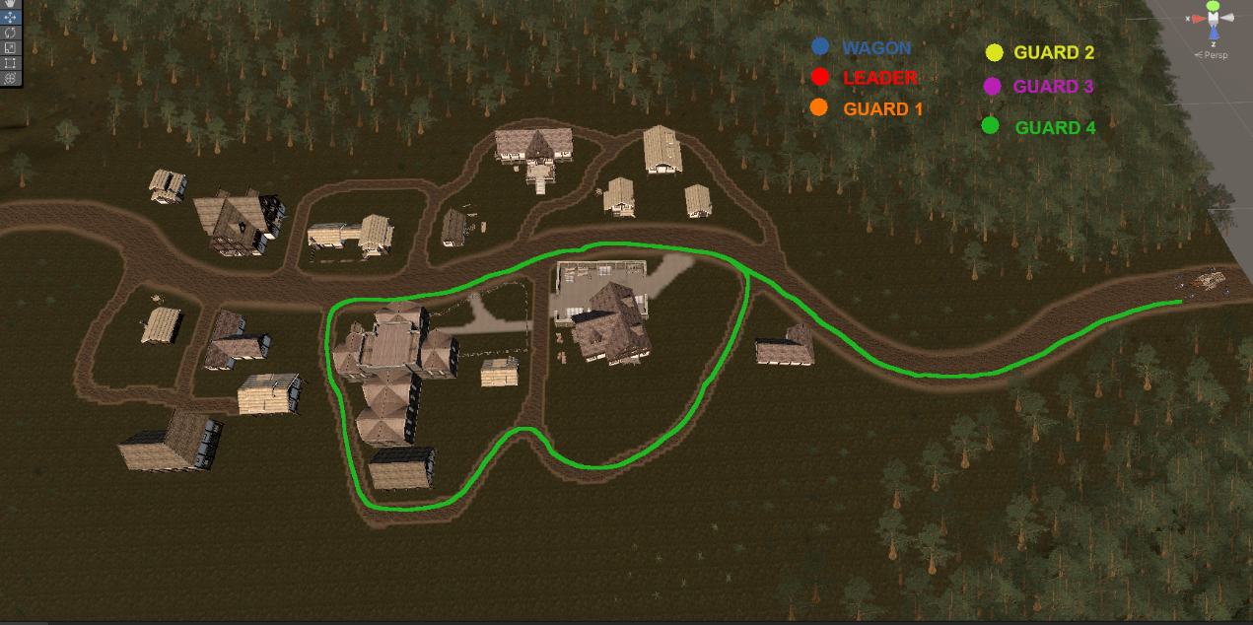

As we enter the village and get stopped, each of the guards begins to patrol around the city. Each guard searches the same sector of the city that they are in relation to the cart.  
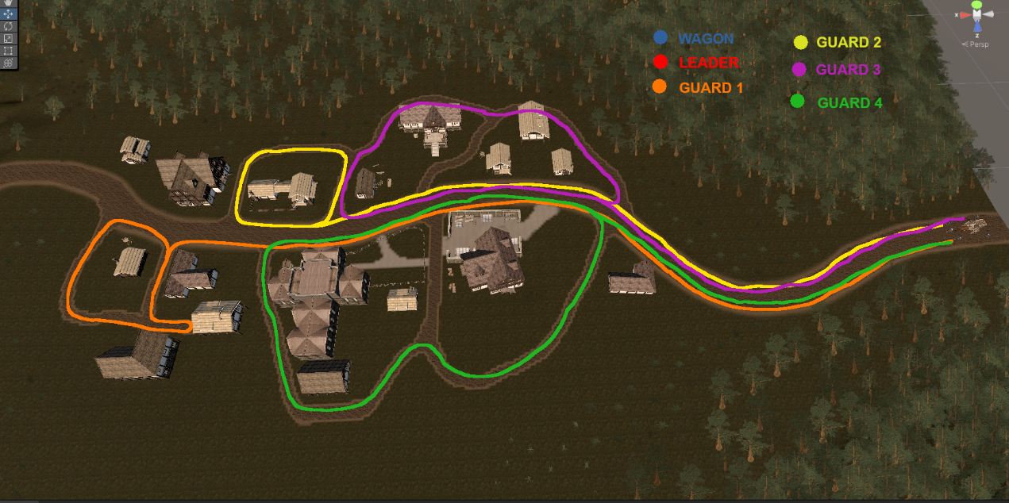

Now for the Leader. It would make more sense to have him more central in the town, so his pathing is shown here:

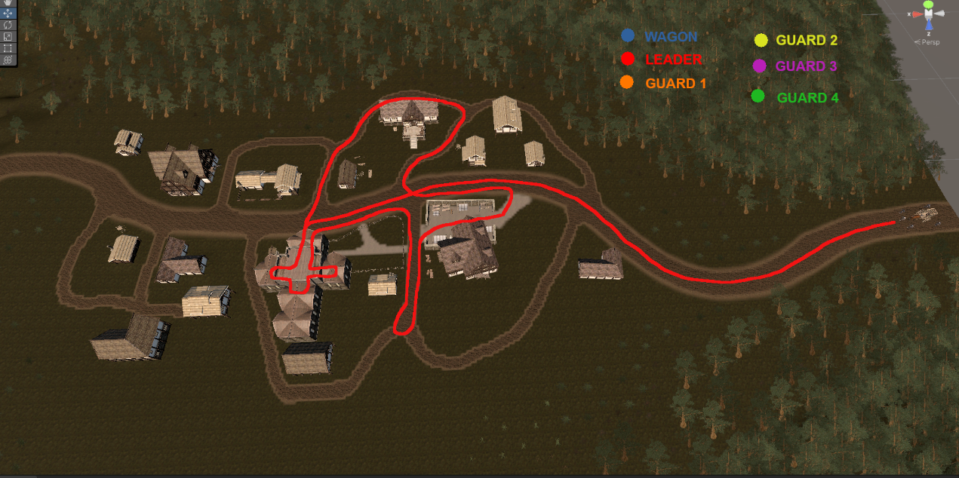

He enters the church immediately upon arrival, then makes a trip around the cemetery, through the market, then up and around the tavern before starting it all again.

With all of these together, we cover all of the inner roads of the town, and even the inside of the church (1 of 2 buildings we can enter).  
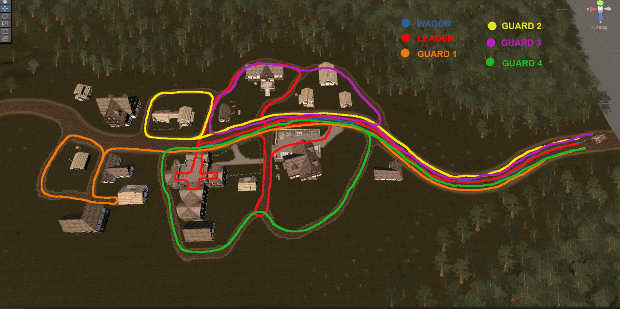

Since the town is filled with enemies, we will need a way to defend ourselves.

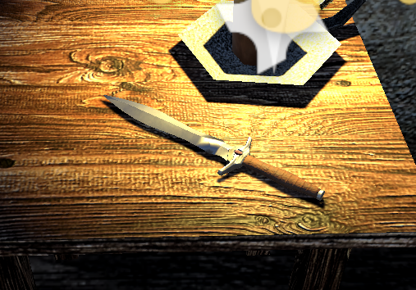

A dagger has been added to the map. Once the player picks this item up, they will be able to attack and kill the enemies.

As of now, we have enough guards to have a patrol of the town. The player will need to find the dagger and take out the guards until he gets the intel (not in game yet) he needs.

There are certain areas that could be easier to cross at different times depending on the path the player chooses to take.

This whole stretch of the main road for instance:

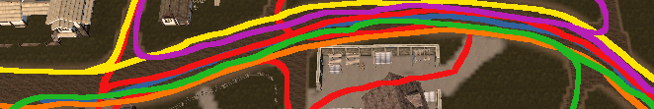

Could have 2 or more patrols at any given time.

This stretch here is another example:  
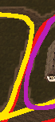

It could have up to 3 guards at once if the timing worked out.

This was a very large area that had no patrol before the leader was added:  
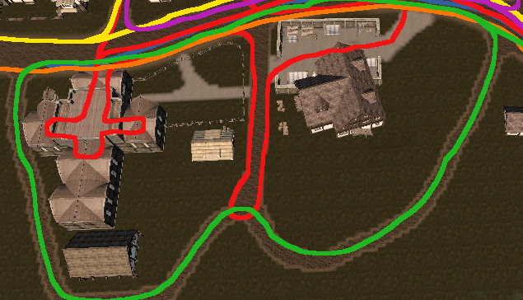

Now, there is more of a threat to taking this route. Especially since the leader goes inside the church and the markets. This will reduce the places to hide and force the player to consider their hiding spots more carefully.